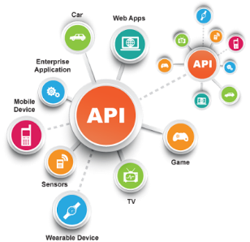**SE495 Software and Systems Integration**

**Chapter 4: Integration Design Patterns Project**

**Project Title: Implementing Integration Design Patterns in a Ride-Sharing Application**

**Objective**

The primary objective of this project is for students to apply integration design patterns in the design and implementation of a ride-sharing application. Through this project, students will gain hands-on experience in using integration design patterns to solve common integration problems.

**Project Requirements**

1. Design and implement a ride-sharing application.
2. Identify integration problems and apply appropriate integration design patterns.
3. Demonstrate the application's ability to handle ride requests, driver assignments, and ride completion.

**Project Steps**

1. **Understand the ride-sharing domain:** Research and understand the ride-sharing domain, focusing on the processes involved in handling ride requests, driver assignments, and ride completion.
2. **Identify integration problems:** Based on the understanding of the ride-sharing domain, identify common integration problems, such as data inconsistency, service coordination, and error handling.
3. **Choose appropriate integration design patterns:** For each identified integration problem, choose an appropriate integration design pattern to solve the problem, such as the Publish-Subscribe pattern, the Aggregator pattern, or the Dead Letter Channel pattern.
4. **Design the ride-sharing application:** Design the overall architecture of the ride-sharing application. Incorporate the chosen integration design patterns into the application design.
5. **Implement the ride-sharing application:** Choose a programming language or framework to build the ride-sharing application. Implement the identified integration patterns in the application.
6. **Test the ride-sharing application:** Test the ride-sharing application to ensure it handles ride requests, driver assignments, and ride completion efficiently and effectively, using the implemented integration design patterns.
7. **Present your solution:** Prepare a presentation or report outlining the ride-sharing application's design, implementation, and test results. Demonstrate how the application handles ride requests, driver assignments, and ride completion using the implemented integration design patterns.